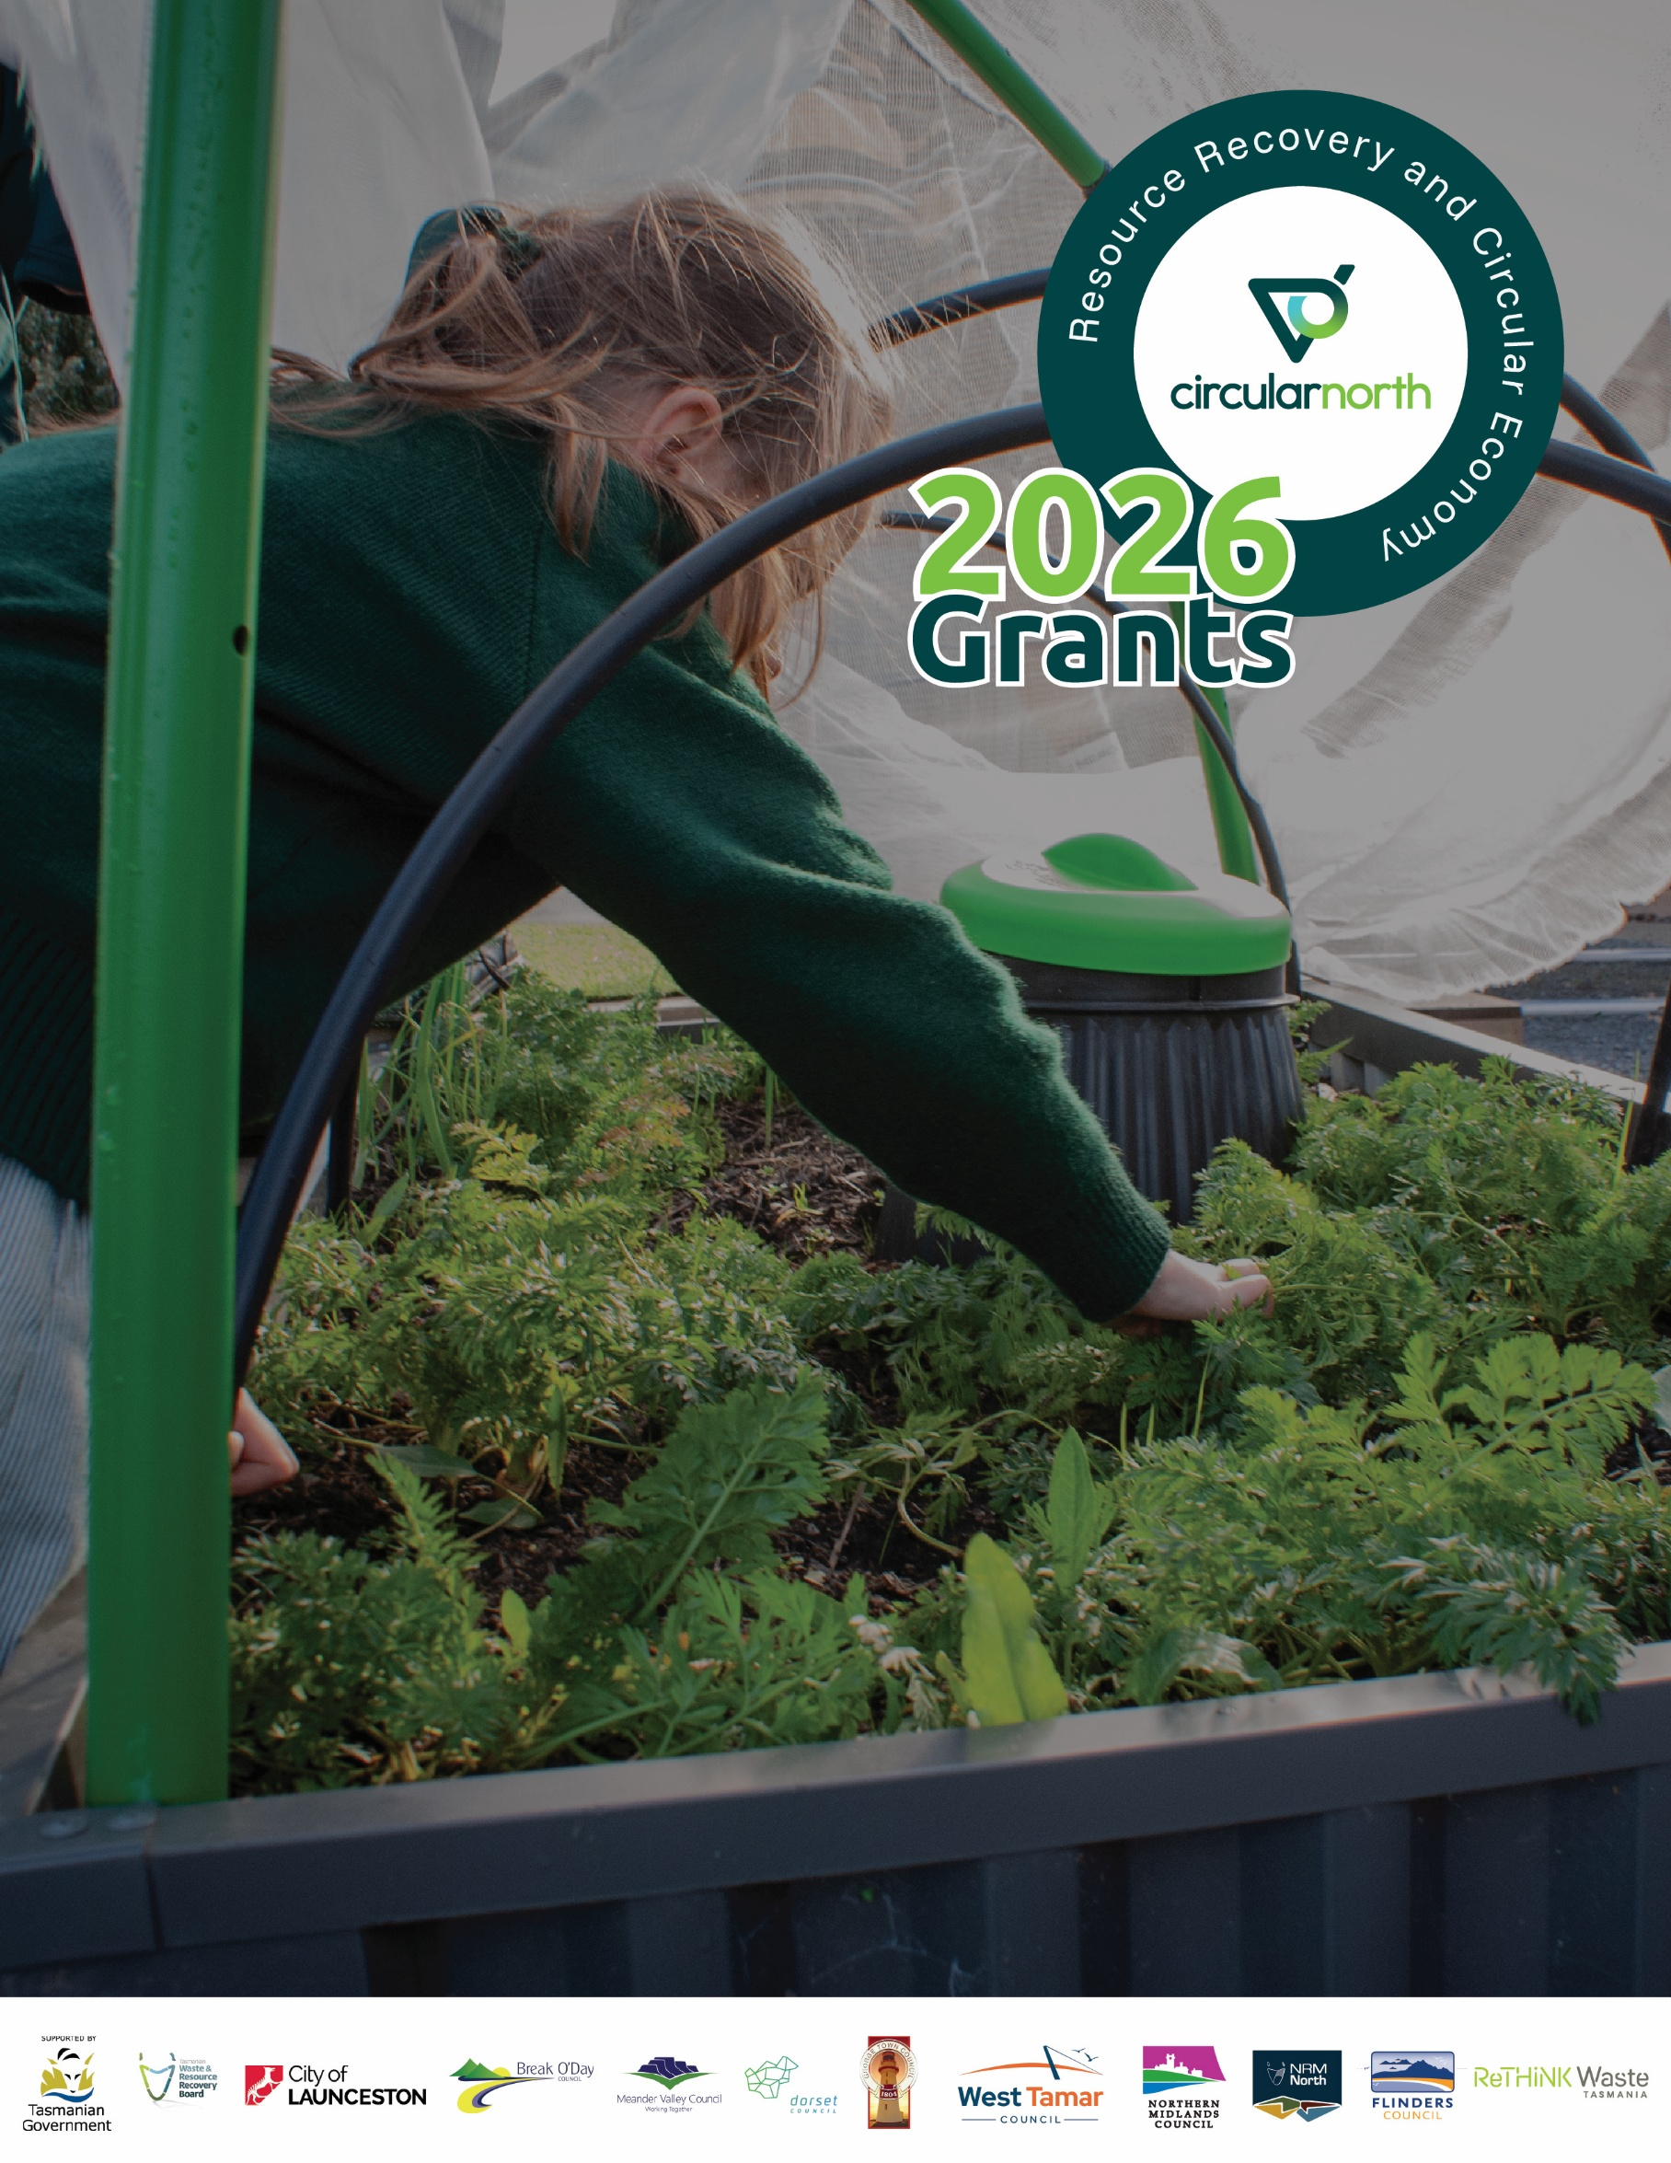

Application Form

Resource Recovery and
Circular Economy Grants 2026

Circular North is supported by the Tasmanian Waste and Resource Recovery Board, which is funded by the Tasmanian Government.

Information in this document is current as of November 2025.

While all professional care has been taken in preparing this document, Circular North, hosted by NRM North, accepts no liability for loss or damages incurred as a result of reliance placed upon its content.

Circular North
Hosted by NRM North
63-65 Cameron Street
Launceston TAS 7250
T: 03 6333 7777
E: circularnorth@nrmnorth.org.au
W: www.circularnorth.org.au

Follow us on Facebook and LinkedIn : @CircularNorth

Resource Recovery and Circular Economy Grants 2026

APPLICATION FORM

Grant application conditions in accordance with application guidelines 4
Section 1 – Applicant contact information 6
Section 2 – Previous recipients of Circular North grants 7
Section 3 – Project overview 7
Section 4 – Supporting information 9
Section 5 – Project budget 10
Section 6 – Financial viability, insurance, agreements, declarations and application submission 12
Checklist 14
Use and disclosure of personal information 15
More information and contact details 16

This form is to be completed after reading the Resource Recovery and Circular Economy Grants 2026 – Application Guidelines.

Applications close at 5pm, Friday 23 January 2026

GLOSSARY
NRM North | Northern Tasmanian Natural Resource Management Association Inc. (Trading as NRM North) ABN 86 015 680 466
CN | Circular North, hosted by NRM North

Grant application conditions in accordance with application guidelines

Grants offered to successful applicants are subject to the following conditions:
- Successful applicants will be required to enter into a funding agreement with NRM North as host of Circular North.
- All projects will be assessed by the Circular North Independent Assessment Panel and endorsed by the Circular North Steering Committee.
- Funding will not be granted to projects prior to a funding agreement being signed with NRM North or before some other formal approval by the Circular North Steering Committee.
- Project expenses incurred prior to an Agreement being signed with NRM North are not eligible for reimbursement.
- Funds must be spent on the project as described in the application and as outlined in the funding agreement, and the project must meet best practice standards. Failure to do so may result in a reduction or withdrawal of funding.
- There is to be no deviation from the funded project prior to and unless approved by the Circular North Steering Committee. The applicant acknowledges that any alterations to the project may result in a reduction or withdrawal of funding.
- Funding will be provided to successful applicants in multiple payments. Successful schools, not-for-profit community organisations and businesses will receive an upfront payment of 50% of the grant amount once relevant paperwork is signed and sent back. Final payment will be granted once all expenditure has incurred and evidence of expenditure must have been provided in the form of tax invoices.
- Projects MUST be finished within twelve months from the date of the funding offer or funding will be withdrawn. An applicant may submit a request for an extension which needs to be in the form of a letter addressed to the Chair of the Circular North Steering Committee, detailing valid reasons why an extension should be granted and how long the extension is being asked for. All extension requests will be put to the Circular North technical and steering committees for approval.
- Applicants who were previous Circular North grant recipients will only be considered for funding if they have completed their previously funded projects. Funding to previous grant recipients will only be provided for new projects or projects which build on previously completed projects.
- Applicants must meet eligibility criteria as specified in the Resource Recovery and Circular Economy Grants 2026 Application Guidelines.
- Successful applicants are required to provide NRM North with satisfactory progress reports via the method nominated by NRM North.
- Successful applicants are required to provide NRM North with a satisfactory final evaluation report twelve months after the completion of the project. (NRM North will provide the report format and template in twelve months' time)
- In accordance with the Circular North Communications guidelines and protocols for external proponents, successful applicants must acknowledge the support of Circular North in all project communications through use of the Circular North logo and the statement: “This project is delivered in partnership with Circular North, supported by the Tasmanian Government, through the Tasmanian Waste and Resource Recovery Board.”
- In accordance with the Circular North Communications guidelines and protocols for external proponents, Circular North must be notified about any public communication made by the applicant about the funded project.
- Information about the project and successful grant recipients will be used by Circular North for program evaluation purposes, case studies, and other promotional purposes.
- Shortlisted commercial/private applicants may need to pass a financial viability check if required by the Circular North Assessment Panel and Steering Committee.
- Applicants must carry out their work with professional skill, care and diligence and in accordance with all laws, codes and standards.
- Applicants must provide any information, report, statement or declaration relating to the project within 14 days of a written request from NRM North.
- Applicants must be, and continue to be, solvent and financially viable to the satisfaction of NRM North in order to receive funding. Applicants will be ineligible, or NRM North will withdraw any funding offer or terminate any funding agreement, if, in the opinion of NRM North, the applicant is not solvent and financially viable.
- The funding grant may be terminated by NRM North by giving written notice to the applicant if the applicant fails to comply with the conditions of this grant; provides false or misleading information; or becomes financially insolvent. If the grant is terminated, NRM North reserves the right to demand repayment of any grant monies paid.
- The applicant hereby indemnifies and agrees to keep indemnified NRM North and Circular North from and against all or any actions, claims, demands, losses, damages costs and expenses for which NRM North and Circular North shall or become liable in respect of or arising from any breach by the applicant or its servants and agents or any person of its obligations under the grant.
- NRM North and Circular North is not liable to the applicant in any circumstance whatsoever for any consequential, indirect or incidental loss, special loss or damage or economic loss, loss of revenue, loss of production or loss of profit (whether direct or indirect).

By submitting a grant application, you agree:
- that you are bound by these conditions, the conditions outlined in any Agreement between you and NRM North, and the conditions set out in the Resource Recovery and Circular Economy Grants 2026 Application Guidelines.
- that you will lodge your application using the prescribed application form, by the closing time and date, in accordance with the lodgement method outlined in the grant documents. Late applications will not be accepted, except as outlined in the guidelines.
- that these conditions, together with the guidelines and the application form, and any other documents specified by the Circular North, form part of the grant.
- to submit all documents as required by the grant guidelines and application form.
- that the grant application documents become NRM North and Circular North property upon lodgement
- to license NRM North and Circular North to collect, hold, use and disclose the whole or any portion of the application documents for evaluation and audit purposes in accordance with the Privacy Act 1988 and the Australian Privacy Principles found in that Act. NRM North warrants that the information will not be used for any purpose other than grant related matters or promotional purposes.

NRM North will:
- confirm electronic receipt of applications.
- reject applications received after the closing time and date, except in accordance with Circular North’s procedures contained in the grant Guidelines.
- facilitate assessment of applications against the evaluation criteria through the Circular North Independent Assessment Panel and the Circular North Steering Committee who will determine which application/s will be funded.
- advise applicants of the outcome of the grant process.
- not be liable for any deficiency within the guidelines and application form or other associated documents.
- not warrant the accuracy of the guidelines and application form.

Circular North may:
- change any details in the guidelines and application form.
- reject any application that does not meet the eligibility criteria.
- contact other local government agencies or departments or any other relevant person to obtain additional information in relation to the grant application.
- negotiate with one or more applicants to change any aspect of their application.

Complete all fields unless advised otherwise

Section 1 – Applicant contact information
Organisation details
Name of organisation:
Primary street address:
Town/Suburb: |  |  |  | Postcode: |  |  | State:
Postal address (if different from above):
Town/Suburb: |  |  |  | Postcode: |  |  | State:
Authorised person - Primary Contact (this is the person who is authorised by the applying organisation to make the application)
Title: |  | First name: |  | Surname:
Position:
Phone: |  |  | Mobile:
Email:
Secondary Contact (this person will only be contacted if the primary contact is not available)
Title: |  | First name: |  | Surname:
Position:
Phone: |  |  | Mobile:
Email:
Type of organisation (select only one):
- ☐ School |  | Type (select only one): |  | ☐ primary | ☐ secondary |  |  | ☐ college
- ☐ Community groups |  | Type (select only one): |  | ☐ not-for-profit |  | ☐ other (see below)
- ☐ Business |  | Size (select only one): |  | ☐ small to medium (0 – 199 employees) |  | ☐ large (> 199 employees)
- ☐ Local government |  | Details (select only one): |  | ☐ council |  | ☐ other (see below)
- ☐ State government |  | Details (select only one): |  | ☐ department |  | ☐ other (see below)
- ☐ Sole trader
If 'other' was selected above, please describe the type of organisation:
Applicant organisation's Australian Business Number (ABN): |  |  |  | Is the organisation registered for GST? |  |  | ☐ Yes ☐No
Number of employees: |  |  |  | Number of volunteers:
How did you find out about the grants?

Section 2 – Previous recipients of Circular North grants
Have you previously received a grant from Circular North / the Northern Tasmanian Waste Management Program / Group (NTWMP/G)? | ☐ Yes | ☐ No | If no, please proceed to section 3.
If you have previously received a grant from Circular North / NTWMP/G, have you successfully completed your project? | ☐ Yes | ☐No
Are you seeking funding for an alternative project to that which was previously funded or a project that extends/builds on a previously funded project? | ☐ New | ☐ Existing

Section 3 – Project overview
- Project manager details (this will be the main contact person for the project). If the same as person listed in Section 1, proceed to Section 3 question 2.
Name:
Email:
Telephone:
Position:

- What is the project name? This name will be used on all correspondence and promotional material. The project name should be no more than ten words.
Name of project:

- Where will your project occur? List the address of where the project will take place or, for a community awareness program, the community groups and locations/suburbs which will be included in the project.
Location of project:

- Project type:
For schools and non-for-profits, select appropriate box(es). Once complete, proceed to question 5.
- procurement of recycling hubs | ☐
- litter management, awareness and prevention | ☐
- community awareness | ☐
- value-add or upcycle of materials destined for landfill | ☐
- infrastructure to promote waste separation | ☐
For other organisations, select appropriate box(es). Once complete, proceed to question 5.
- procurement of recycling hubs | ☐
- innovative recycling infrastructure and landfill diversion | ☐
- litter and recycling management, awareness and prevention | ☐
- value-adding or upcycling of waste/discarded materials | ☐
- community awareness | ☐

Project description
- Describe your project: Include details of what your project involves and how it will be implemented. You may also want to describe how your project improves on the current situation at your workplace or within the community. (Maximum 200 words)

- Community benefit: Describe how your project will benefit the northern Tasmanian community and how this benefit will continue to be realised beyond the term of the grant contract. (Maximum 150 words)

- Project duration: How many years will the project provide benefits to the northern Tasmanian community? (Maximum 100 words)

- Commitment: Explain your organisation's commitment to improving waste management and recycling, in addition to applying to this grants program. (Maximum 150 words)

- Landfill diversion: What quantity of waste is estimated / anticipated to be diverted from landfill per annum, following completion of the project? (Provide tonnes)
Tonnes:

- For applications seeking to install bin infrastructure, will bin bodies and bin lids meet Australian Standards for bin colours (AS 4123-2006 part 7)?
Yes ☐ | No ☐ | N/A ☐

- Project duration: How long will your project take to complete and why? (Maximum 100 words)

Section 4 – Supporting information

- Supporting information from all applicants
Provide a brief outline (200–300 words) of how the project will be managed over the next five years.
- Supporting information from schools only
Describe how the project aligns with Key Learning Areas of the Australian Curriculum (maximum 400 words) All 'other' organisations are to proceed to question 14.
- Supporting information from applicants installing infrastructure only
If the project involves infrastructure development/installation, provide a brief outline (maximum 300 words) of how all users of the system, including maintenance staff, will be educated as to its purpose and proper operation. Applicants not installing infrastructure are to proceed to section 5.

Section 5 – Project budget
Complete the budget tables (part A and part B) detailing the project income and expenditure, including the amount of funding requested, and the cash and/or in-kind contributions (see tables below).
- If you are committing in-kind contributions as part of your project budget, you must provide details in the template below and sign the declaration at the end of the application form.
- At least two written quotations must be provided for all expenditure items for which the Circular North has been asked to contribute funding towards. Quotes can include evidence from suppliers obtained through online search functions. (Prior approval must be sought from the Circular North if the applicant is unable to source two valid quotes).
- You must declare the expenditure items listed in the project budget table below as a true and accurate record/assessment. The declaration is in section 6.
Funding availability
- Upon execution of the funding agreement with successful grant recipients, 50% of the approved project amount will be payable by NRM North on behalf of Circular North to the grantee upon receipt of a correctly rendered tax invoice.
- Payment on project completion will require evidence of expenditure to demonstrate costs incurred in project delivery.
- Funding is available for eligible items only. Ineligible items will not receive funding.
- The maximum funding amount per application is $10,000 (ex-GST).
- Circular North may request additional financial information during the assessment process.
- PART A: Budget Summary (GST exclusive)
Total eligible project cost (ex-GST) | $
Amount of funding requested from Circular North (ex-GST) | $
Circular North funding as a percentage of total eligible project costs (note: funding is capped at 50% of total eligible project costs. Information on eligible project costs is provided in the Resource Recovery and Circular Economy Grants 2026 - Application Guidelines) | %

Project expenditure (ex-GST): List expense line items separately e.g. materials, advertising, pro-bono hours etc. | Cost | Quotes provided (Ex GST) |  | Applicant contribution |  | Cash contribution from Circular North
 | Cost |  |  | Cash | In-kind* | Cash contribution from Circular North
Provide brief description of expenditure item | $ | Yes☐ | No ☐ | $ | $ | $
Provide brief description of expenditure item | $ | Yes☐ | No ☐ | $ | $ | $
Provide brief description of expenditure item | $ | Yes☐ | No ☐ | $ | $ | $
Provide brief description of expenditure item | $ | Yes☐ | No ☐ | $ | $ | $
Provide brief description of expenditure item | $ | Yes☐ | No ☐ | $ | $ | $
Provide brief description of expenditure item | $ | Yes☐ | No ☐ | $ | $ | $
Provide brief description of expenditure item | $ | Yes☐ | No ☐ | $ | $ | $
Total expenditure (ex-GST) | $ |  |  | $ | $ | $
- PART B: Detailed budget information
Please provide details of your project’s income, excluding GST. Note that total income should equal total expenditure. You are required to submit your budget using the categories provided noting that not all categories will be relevant to your project. In this instance enter the amount as zero. If additional information is required to support the income or expense item in the table below, please provide a summary here and further details on a separate sheet (or sheets) referencing the relevant categories.
Project income (ex-GST)
Amount requested from Circular North | $
Cash contribution from your organisation | $
In-kind contribution from your organisation* | $
Other funding (please specify) | $
Other funding (please specify) | $
Other funding (please specify) | $
Total income | $

*In-kind contributions are only permitted for schools and not-for-profit organisations. Applicants must sign an in-kind costs declaration in Section 6D.
NOTE: All quotes must be Exclusive of GST to be eligible for grant consideration.

Section 6 – Financial viability, insurance, agreements, declarations and application submission

6A. Insurance – all applicants
Please enter the details of insurances held. Certificates of Currency will need to be provided if your funding application is successful.
- Insurance
Name of insurance company
Insurance type | Public Liability
Policy number/s
Expiry dates
Policy amount
Successful applicants will be required to provide additional insurance information including Public Liability and Worker's Compensation (where applicable) certificates of currency before receiving any payment

6B. Infringements and conflict of interest – all applicants
- Infringement notices
Does your organisation have any current investigations, prosecutions or other enforcement action (such as a notice advising of a breach requiring action by your organisation) that is yet to be complied with, or any findings of guilt, fines or other penalties imposed by a court or by the regulators (Environment Protection Authority Tasmania, WorkSafe Tasmania, others) in the last 10 years? (Note that Circular North may confirm your response with the relevant regulators.)
☐Yes ☐ No
If you answered yes, please provide details:

- Conflict of interest: please select the appropriate box below.
☐ I declare no current or potential conflict of interest, pecuniary or non-pecuniary exists in the context of delivering the project detailed in this application.  (Conflict of interest means any matter, circumstance, interest or activity affecting the applicant or its related persons which may or may not appear to impair the ability of the applicant to undertake the project diligently and independently, or perform its obligations under any funding agreement with Circular North hosted by NRM North in relation to the project.) | ☐ I disclose the following conflict/s of interest and indicate below how I propose to manage it/them in the context of delivering the project detailed in this application.

6C. Financial viability – commercial applicants only (non-commercial applicants, proceed to 6D – Agreement & Declaration)
- Financial viability (commercial applicants only): NRM North, on behalf of Circular North, may undertake a financial viability assessment of commercial organisations before offering funding or while projects are implemented. Financial documentation to the satisfaction of the NRM North is required to be submitted upon request to NRM North, on behalf of Circular North, to enable this assessment to occur. (NOTE: all financial information will be kept confidential.)
☐ I declare that, as an authorised person, the applicant organisation will meet these terms.
Signature: | Click here to enter text. | Date:
Print name: |  | Position:
(To be signed by a person with delegated authority to apply – i.e. CEO, GM, Director, Principal, chairperson, secretary, public officer or treasurer of the applicant organisation.)

6D. Declaration – schools and non-profit community groups / organisations only: In-kind contributions
Declaration
- Maximum funding is restricted to the federal award rates for any type of labour provided e.g. teacher or maintenance staff time – as indicated by Fair Work www.fairwork.gov.au
- Volunteer time cannot be counted as in-kind support.
- Pro-bono in-kind hours included in the application budget and project report refers to those hours a community member would normally charge for their time and skills for performing professional services.
- Provide a statement of staff or pro-bono hours certified as true and accurate by the organisation's chief financial officer (or equivalent) as evidence of in-kind contribution on project completion.
- Existing salary costs cannot be counted as in-kind support. In-kind support can only be claimed for hours required to deliver the project.
- In-kind support cannot total more than 50% of total eligible project costs.
☐ I declare that, as an authorised person, the applicant organisation will meet these terms.
Signature: | Click here to enter text. | Date:
Print name: |  | Position:
(To be signed by a person with delegated authority to apply – i.e. Principal, CEO, GM, Director, chairperson, secretary, public officer or treasurer of the applicant organisation.)

6E. Agreement & Declaration – all applicants
PART A: Agreement
- I agree to submit a report at the conclusion of the funded project which will form part of the evidence of completion of the project required by Circular North prior to final payment being authorised.
- Where requested by Circular North, I agree to facilitate nominated waste assessors to attend the project site for a pre- and post-program waste assessment to demonstrate the effectiveness of the implemented infrastructure, education or awareness raising programs (this will be at no cost to the successful applicant and prior approval will be sort and a time mutually agreed).
- Where applicable I MUST apply the Circular North logo on the items the grant has assisted funding for e.g. brochures or infrastructure, in accordance with Circular North’s communication guidelines.
- I MUST acknowledge the support of Circular North in all project communications and Circular North MUST be notified about any public communication made by the applicant about the funded project.
☐ I declare that, as an authorised person, the applicant organisation will meet these terms.

PART B: Declaration. By checking the box and signing below, I declare that:
- the information in this application and attachments is to the best of my knowledge true and correct and agree to the grant application conditions.
- I will notify Circular North of any changes to this information and any circumstances that may affect this application.
- I acknowledge Circular North may refer this application to external experts or other local government departments or agencies for assessment, reporting, advice, comment or for discussions regarding alternative or collaborative grant funding opportunities.
- I understand NRM North, the host of Circular North is subject to the Right to Information Act 2009 and that if a Right to Information request is made, NRM North will consult with the applicant before any decision is made to release the application or supporting documentation.
- I understand that this is an application only and may not necessarily result in funding approval.
- The costs for the project outlined in the project budget in Section 4 are a true and correct record/assessment of the relevant costs associated with the project described in Section 3.
- I have read and confirm the applicant organisation agrees to the grant application conditions in accordance with application guidelines included within this funding application form.
☐ I declare that, as an authorised person, the applicant organisation will meet these terms.
Signature: | Click here to enter text. | Date:
Print name: |  | Position:
(To be signed by a person with delegated authority to apply – i.e. chairperson, secretary, public officer or treasurer of the applicant organisation.)

Checklist
For all applicants:
I have read and understood the Application Guidelines | Yes ☐ | No ☐
Application Form completed (compulsory) | Yes ☐ | No ☐
Two written quotations (compulsory – refer Section 5) | Yes ☐ | No ☐
Supporting documentation (optional): for example, letters of support etc. | Yes ☐ | No ☐
Quotations and supporting documents are attached alongside this form to email being sent to circularnorth@nrmnorth.org.au | Yes ☐ | No ☐

Applications close at 5pm, Friday 23 January 2026

Use and disclosure of personal information
Circular North is hosted by NRM North, which is also a member of Circular North.
NRM North's employees, including Circular North project staff, are only provided with or have access to the information that is necessary for them to carry out their functions within Circular North. All employees have agreed to comply with the requirements of the Personal Information Protection Act 2004. Personal information will be used only for the purpose for which it was collected, or a related purpose that you would reasonably expect.
Some important interests such as protecting health and safety, welfare, or prevention and investigation of crimes can justify the use and disclosure of personal information without consent. Otherwise, your personal information will only be disclosed with your consent, or if it is required by or authorised by law. A specific example is when you make a representation about a development application; your details will then become a matter of public record.
There may be a need or requirement to disclose some or all information NRM North collects to contractors, service providers and agents of NRM North, law enforcement agencies, courts or other public sector bodies.
The Personal Information Protection Act 2004 permits the disclosure of "basic personal information" (that is, name, address, date of birth and gender) to other public sector bodies, where necessary, for the efficient storage and use of information.
Access to and Correction of Information Collected
The Personal Information Protection Act 2004 provides that you can access your personal information held by NRM North.
If you consider the personal information to be incorrect, incomplete, out of date or misleading, you can request that the information be amended.
Requests to access or correct your personal information held by NRM North or Circular North will be processed in accordance with the provisions of the Right to Information Act 2009.

More information and contact details

For more information, please contact Circular North by phone or email.

Circular North
Hosted by NRM North
63-65 Cameron Street
Launceston TAS 7250
T: 03 6333 7777

E: circularnorth@nrmnorth.org.au
W: www.circularnorth.org.au

Follow us on Facebook and LinkedIn : @CircularNorth

